**Supplementary Materials**

**Recordings of the experimental task, the data, the stimuli and the analysis scripts are available on the following link:** <https://doi.org/10.18743/DATA.00088>

**Reaction time data**

Participants contributed a total of 3568 correct trials in the first block (M = 108.12, SD = 10.03) and a total of 2836 correct trials in the second block (M = 85.93, SD = 9.94). Kolmogorov-Smirnov tests indicated that the data was normally distributed in both experimental blocks (Block1: D(33) = 0.121, p = 0.200, M = 1.49, SE = 0.037; Block2: D(33) = 0.103, p = 0.200, M = 1.55, SE = 0.032.) Response times that were more than 3 standard deviations away from the mean in the relevant experimental block were removed, which resulted in a less than 1% reduction in the data.

Response times on correct trials were submitted to a 4 X 3 X 2 repeated measures ANOVA with the independent variables Condition (I-NC/I-C/E-NC/E-C), Pattern density (Sparse/Medium density/Dense) and Pattern size (Block1: Small pattern/Block2: Large pattern). All pairwise comparisons were Bonferroni corrected. The results of the ANOVA are discussed below along with our predictions regarding Condition, Pattern density and Pattern size. The predictions are closely aligned with the predictions regarding accuracy, which is discussed in the main analysis.

1. *Condition*

Response times were predicted to be faster when responding to a target location that was previously filled (I-NC and I-C), compared to when it was previously empty (E-NC and E-C). Responses were predicted to be fastest when the target location was filled both during encoding and at the outcome (I-NC), and slowest when an empty target location remained empty (E-NC). Descriptive statistics of participants’ response times in the four conditions are displayed in Table S2.

In line with these predictions, the ANOVA resulted in a main effect of Condition, *F*(3,96) = 35.38, p < 0.001, ηp2 = 0.536 (Figure S1). Responses were fastest in the item/no change condition (M = 1070.81, SE = 37.72), which was significantly different from all other conditions (p < 0.001 in all three comparisons). Responses were slowest in the empty/no change condition (M = 1401.14, SE = 40.88; E-NC/I-NC: p < 0.001; E-NC/E-C: p < 0.001; E-NC/I-C: p = 0.112).

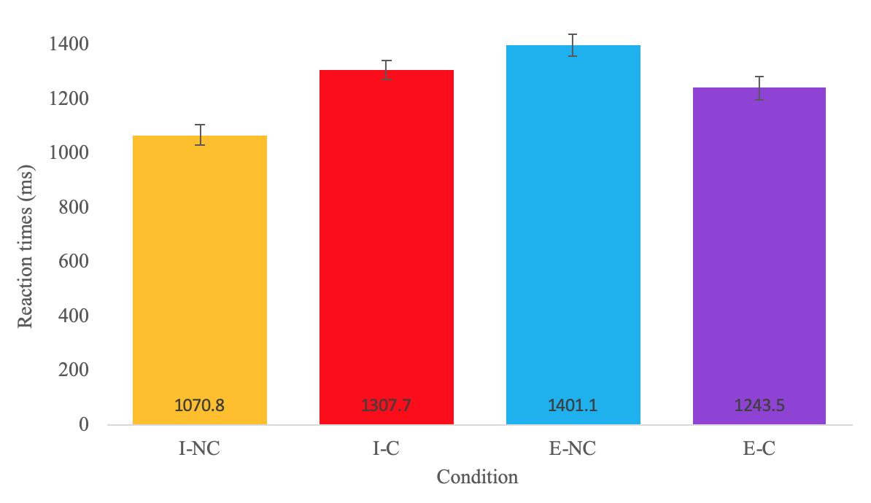

*Figure* S1. Reaction times on correct trials across conditions. Responses were fastest in the item/no change condition and slowest in the empty/no change condition.

In addition, we tested whether the main effect of Condition was driven by the identity of the target location during encoding (empty: E-NC, E-C; filled: I-NC, I-C) or the identity of the location at the outcome (empty: E-NC, I-C; filled: E-C, I-NC). Response times in the four conditions were submitted to a 2 x 2 ANOVA with the independent variables Encoded location (Empty/Filled) and Outcome location (Empty/Filled). This resulted in a main effect of Encoded location, with significantly slower responses if the target location was empty during encoding, *F*(1,32) = 76.4, p < 0.001, ηp2 = 0.705 (Empty at encoding: M = 1669, SE = 43.5; Filled at encoding: M = 1482.49, SE = 37.49). In addition, empty outcome locations were associated with slower response times than filled outcome locations: main effect of Outcome location, *F*(32) = 9.17, p = 0.005, ηp2 = 0.223 (Empty outcome: M = 1605.96, SE = 40.45; Filled outcome: M = 1545.68, SE = 40.41).

Importantly, a highly significant Encoded location X Outcome location interaction, *F*(1,32) = 424.55, p < 0.001, ηp2 = 0.930, indicated that responses were fastest when the location was filled during both the encoding and at the outcome (I-NC: M = 1070, SE = 37.72) and slowest when an empty location remained empty (M = 1401.14, SE = 40.88).

These results confirm that both encoding and responding to an empty location results in slower response times compared to filled locations.

1. *Pattern density*

If the target location is represented as a separate unit of information, then encoding the target amongst multiple identical items will hinder performance. Namely, encoding an item will be harder in the presence of multiple other items (dense patterns), and encoding an empty location will be harder in the presence of multiple other empty locations (sparse patterns). However, according to our hypothesis, empty locations are not represented as unique pieces of information, but as part of the global pattern. Therefore, increasing the number of items in the pattern was predicted to impair performance when tested on an item (I-NC, I-C), while increasing the number of empty locations in the pattern was predicted to have a less pronounced effect when tested on an empty location (E-NC, E-C). Descriptive statistics of response times as a function of pattern density are displayed in Table S5.

A significant Condition X Pattern density interaction, *F*(6,192) = 3.85, p = 0.001, ηp2 = 0.107, revealed that the ratio in which the two types of content were presented affected response times differently depending on the Condition (Figure S2 a). Presenting more items significantly impaired performance in the item/change and item/no change conditions (linear trends: I-NC, *F*(1,32) = 41.38, p < 0.001; I-C, *F*(1,32) = 45.05, p < 0.001). In addition, presenting more empty locations slowed down responses in the empty/change condition (linear trend: E-C, *F*(1,32) = 11.06, p = 0.002), while responding in the empty/no change condition was slowest when the two types of content was presented equally (quadratic trend: E-NC, *F*(1,32) = 11.48, p = 0.002).

The impairment resulting from encoding the target amongst multiple identical locations (i.e. an item in a dense pattern or an empty location in a sparse pattern) was compared across conditions (Figure S2 b). The largest impairment by varying the ratio of items and empty locations in the pattern occurred in the item/no change condition, followed by the item/change condition (I-NC/I-C: t < 2, p > 0.1). Performance in the empty/change condition was significantly *less* impaired (I-C/E-C: p = 0.043). Lastly, the ratio of items and empty locations had the smallest impact on the empty/no change condition (E-C/E-NC: t < 2, p > 0.1).

a



b

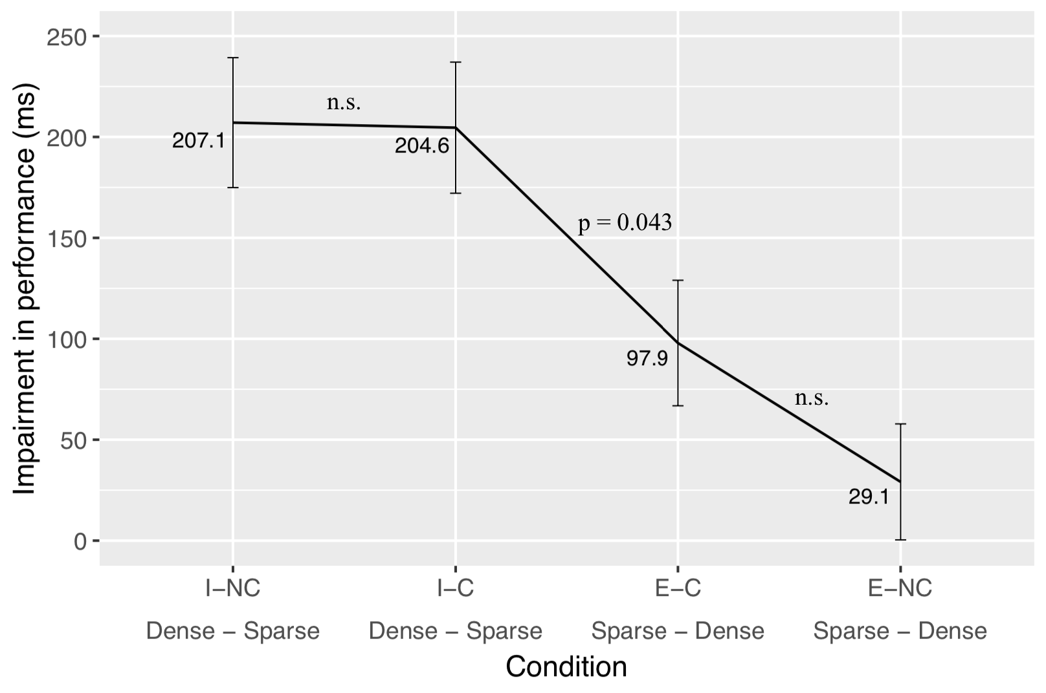

*Figure* S2. The impact of pattern density on reaction times in the four conditions. a) Performance at Sparse, Medium density and Sparse patterns in the four conditions. b) The impairment resulting from presenting the target amongst multiple identical locations. Difference scores were calculated by subtracting reaction times when the target was presented amongst multiple identical locations from the reaction times when the target location was more salient (Dense – Sparse when encoding items and Sparse – Dense when encoding empty locations).

Therefore, in line with our predictions, increasing the number of items in the pattern significantly impaired performance on the items (I-NC, I-C), while increasing the number of empty locations in the pattern had a less pronounced effect on reaction times (E-NC, E-C).

1. *Pattern size*

Similarly to our predictions regarding accuracy, the size of the overall pattern was predicted to impact performance more when the target location was empty during encoding (E-NC, E-C) compared to when it was filled (I-C, I-NC). Descriptive statistics of response times as a function of pattern size are displayed in Table S6.

The main effect of pattern size was not significant, indicating that increasing the size of the overall configuration did not have an independent effect on reaction times, *F*(1,32) = 1.01, p = 0.325, ηp2 = 0.030. Crucially, however, the ANOVA resulted in a significant Condition X Pattern size interaction, *F*(3,96) = 6.04, p = 0.001, ηp2 = 0.159, confirming that increasing the size of the overall pattern from 4 to 8 tracked locations had a different impact on response times depending on the condition (Figure S3).

Response times after encoding small and large patterns were not significantly different in the item/no change and item/change conditions (I-NC, *t*(32) = 1.14, p = 0.260; I-C, *t*(32) = 0.39, p = 0.695). Doubling the size of to-be-remembered locations did not affect reaction times when the participant was tested on an item, indicating that the representations of items were independent from the representations held on other locations, therefore, if the encoding of the item was successful, then responding was not slowed down by the number of other locations that had also been encoded.

In contrast, performance was significantly impaired at larger patterns if the participant was tested on an empty location (E-NC, *t*(32) = 4.21, p < 0.001; E-C: *t*(32) = 5.54, p < 0.001), suggesting that the entire pattern had to be retrieved in order to respond correctly, which in turn slowed down response times in these conditions.



*Figure* S3. The effect of pattern size on the four conditions. While responses were slower after encoding large patterns when tested on an empty location (E-NC, E-C), response times were unaffected by the size of the overall pattern when tested on an item (I-NC, I-C).

**Gaze data**

As reported in the analysis of gaze data, participants spent significantly shorter amount of time looking at empty locations as opposed to filled locations in both blocks. Mean target looking to items was 1140.3ms in the first block (SE = 203.1ms) and 489.3ms in the second block (SE = 120.4ms). In contrast, average looking times to *empty* locations were 168.3ms in the first block (SE = 65.6ms) and 69.6ms in the second block (SE = 42.8ms). The number of correct trials over all trials (Figure S4) and the proportion of correct trials over all trials (Figure S5) were calculated within 500ms time bins in case of filled and empty target locations.

The graphs indicate larger gaps between the amount of correct trials over all attempted trials in case of empty locations within the same time windows, which suggests that poor performance on the empty locations cannot be attributed to shorter encoding times alone.

a

** **

b

** **

*Figure* S4. Total number of correct trials as compared to all trials as a function of target location, collapsed across participants. a) Block 1 (4 tracked locations) b) Block 2 (8 tracked locations). A total of 33 participants were presented with a total of 1980 filled locations and 1980 empty locations in each of the experimental blocks. (60 trials involving a filled location and 60 trials involving an empty location in each block for each participant). The dashed lines indicate the amount of time dedicated to the target location by an ideal observer (5000ms encoding time/the number of locations: 1250ms in Block1 and 625ms in Block2). The blue and red dashed lines indicate the average target looking times observed in the data with regard to filled and empty locations, respectively. (Filled target/Block1: M = 1140.3ms, SE = 203.1ms; Filled target/Block2: 489.3ms, SE = 120.4ms; Empty target/Block1: M = 168.3ms, SE = 65.6ms; Empty target/Block2: M = 69.6ms, SE = 42.8ms). Only valid trials were included in this analysis (>70% gaze data across the 5s encoding interval).

** **

a

b

** **

*Figure* S5. Proportion of correct trials as compared to all trials as a function of target location, collapsed across participants. a) Block 1 (4 tracked locations) b) Block 2 (8 tracked locations). The dashed lines indicate the amount of time dedicated to the target location by an ideal observer (5000ms encoding time/the number of locations: 1250ms in Block1 and 625ms in Block2). The blue and red dashed lines indicate the average target looking times observed in the data with regard to filled and empty locations, respectively. (Filled target/Block1: M = 1140.3ms, SE = 203.1ms; Filled target/Block2: 489.3ms, SE = 120.4ms; Empty target/Block1: M = 168.3ms, SE = 65.6ms; Empty target/Block2: M = 69.6ms, SE = 42.8ms). Only valid trials were included in this analysis (>70% gaze data across the 5s encoding interval).

**Table S1. Percentage of correct trials in the training block and the two experimental blocks**

|  |  |  |  |
| --- | --- | --- | --- |
| ID | Training trials  (% correct)  Chance level: 65% | Block4  (% correct)  Chance level: 57.5% | Block8  (% correct)  Chance level: 57.5% |
| 1 | 85 | 96.66 | 83.33 |
| 2 | 95 | 83.33 | 72.5 |
| 3 (excluded) | 60 | 53.33 | 51.66 |
| 4 | 90 | 93.33 | 78.33 |
| 5 | 100 | 91.66 | 83.33 |
| 6 (excluded) | 45 | 50.83 | 53.33 |
| 7 (excluded) | 100 | 83.33 | 54.16 |
| 8 | 100 | 92.5 | 74.16 |
| 9 | 90 | 97.5 | 82.5 |
| 10 | 100 | 90 | 61.66 |
| 11 | 95 | 85 | 66.66 |
| 12 | 90 | 96.66 | 84.16 |
| 13 | 90 | 94.16 | 73.33 |
| 14 | 90 | 94.16 | 75.83 |
| 15 | 95 | 92.50 | 73.33 |
| 16 | 75 | 99.16 | 76.66 |
| 17 | 95 | 58.33 | 62.50 |
| 18 | 95 | 95 | 77.50 |
| 19 | 90 | 92.50 | 71.66 |
| 20 | 90 | 83.33 | 60.83 |
| 21 | 85 | 99.16 | 77.50 |
| 22 | 75 | 71.66 | 58.33 |
| 23 | 100 | 94.16 | 64.16 |
| 24 | 95 | 95.83 | 77.50 |
| 25 | 90 | 93.33 | 68.33 |
| 26 | 90 | 90.83 | 76.66 |
| 27 (excluded) | 55 | 72.50 | 53.33 |
| 28 | 85 | 89.16 | 63.33 |
| 29 | 100 | 95.83 | 70.83 |
| 30 | 95 | 86.66 | 65 |
| 31 | 90 | 95 | 64.16 |
| 32 | 65 | 78.33 | 66.66 |
| 33 | 95 | 92.5 | 68.33 |
| 34 | 100 | 85 | 59.16 |
| 35 | 100 | 90.83 | 81.66 |
| 36 | 90 | 95.83 | 80 |
| 37 | 100 | 83.33 | 58.33 |
| 38 (excluded) | 100 | 72.5 | 45 |
| **Mean**  (included participants) | **91.51** | **90.10** | **71.61** |
| **SD**  (included participants) | **8.05** | **8.36** | **8.01** |

**Table S2. Descriptive statistics of the percentage of correct responses and reaction times as a function of Condition. Accuracy in each condition in each experimental block was compared to the test values of 100 and 50 using one-sample t-tests.**

|  |  |  |  |  |
| --- | --- | --- | --- | --- |
| Condition  Block1:  Small pattern Block2:  Large pattern | Accuracy  (% of correct responses) | Reaction times (ms) | Test statistics comparing accuracy to 100%  (ceiling) | Test statistics comparing accuracy to 50%  (chance) |
| Block 1 I-NC | M = 94.29  SE = 1.15 | M = 1077.6  SE = 45.8 | *t*(32) = 4.95  p < 0.001 | *t*(32) = 38.44  p < 0.001 |
| Block 2 I-NC | M = 85.19  SE = 2.15 | M = 1064.1  SE = 42.0 | *t*(32) = 6.87  p < 0.001 | *t*(32) = 16.33  p < 0.001 |
| **I-NC Total** | **M = 90.97**  **SE = 1.12** | **M = 1070.8**  **SE = 37.7** |  |  |
| Block 1 I-C | M = 90.28  SE = 1.59 | M = 1356.3  SE = SE = 48.0 | *t*(32) = 6.07  p < 0.001 | *t*(32) = 25.18  p < 0.001 |
| Block 2 I-C | M = 76.56  SE = 2.55 | M = 1259.1  SE = 35.9 | *t*(32) = 9.17  p < 0.001 | *t*(32) = 10.39  p < 0.001 |
| **I-C Total** | **M = 85.13**  **SE = 1.66** | **M = 1307.7**  **SE = 34.8** |  |  |
| Block 1 E-NC | M = 84.93  SE = 2.51 | M = 1353.2  SE = 51.3 | *t*(32) = 5.99  p < 0.001 | *t*(32) = 13.89  p < 0.001 |
| Block 2 E-NC | M = 58.97  SE = 2.64 | M = 1449.1  SE = 48.2 | *t*(32) = 15.56  p < 0.001 | *t*(32) = 3.41  p = 0.002 |
| **E-NC Total** | **M = 74.73**  **SE = 1.63** | **M = 1401.1**  **SE = 40.8** |  |  |
| Block 1 E-C | M = 90.96  SE = 1.74 | M = 1170.6  SE = 43.2 | *t*(32) = 5.19  p < 0.001 | *t*(32) = 23.53  p < 0.001 |
| Block2 E-C | M = 65.91  SE = 2.53 | M = 1316.5  SE = 54.4 | *t*(32) = 13.47  p < 0.001 | *t*(32) = 6.28  p < 0.001 |
| **E-C Total** | **M = 80.37**  **SE = 1.66** | **M = 1243.5**  **SE = 41.9** |  |  |

**Table S3. Analysis of variance conducted on the accuracy data with the independent variables Condition (I-C/I-NC/E-C/E-NC) X Pattern density (Sparse/Medium/Dense) X Pattern size (Small/Large).**

|  |  |  |  |  |
| --- | --- | --- | --- | --- |
| Effect | df | *F* | p | ηp2 |
| Condition | (3, 96) | 36.33 | <0.001* | 0.532 |
| Pattern density | (2, 64) | 11.86 | <0.001* | 0.270 |
| Pattern size | (1, 32) | 208.20 | <0.001* | 0.867 |
| Condition X Pattern density | (6, 192) | 3.61 | 0.002* | 0.101 |
| Condition X Pattern size | (3, 96) | 10.95 | <0.001* | 0.255 |
| Pattern density X Pattern size | (2, 64) | 1.28 | 0.283 | 0.039 |
| Condition X Pattern density X Pattern size | (6, 192) | 1.19 | 0.309 | 0.036 |

**Table S4. Analysis of variance conducted on the reaction time data with the independent variables Condition (I-C/I-NC/E-C/E-NC) X Pattern density (Sparse/Medium/Dense) X Pattern size (Small/Large). No other effects approached significance.**

|  |  |  |  |  |
| --- | --- | --- | --- | --- |
| Effect | df | *F* | p | ηp2 |
| Condition | (3, 96) | 35.38 | <0.001* | 0.536 |
| Pattern density | (2, 64) | 0.88 | 0.419 | 0.027 |
| Pattern size | (1, 32) | 1.01 | 0.325 | 0.030 |
| Condition X Pattern density | (6, 192) | 3.85 | 0.001* | 0.107 |
| Condition X Pattern size | (3, 96) | 6.04 | 0.001* | 0.159 |
| Pattern density X Pattern size | (2, 64) | 1.63 | 0.203 | 0.049 |
| Condition X Pattern density X Pattern size | (6, 192) | 0.47 | 0.826 | 0.015 |

**Table S5. Descriptive statistics of the percentage of correct responses and reaction times as a function of Pattern density. The ratio of items and empty locations was 3:1 in dense patterns, 1:1 in medium density patterns, and 1:3 in sparse patterns.**

|  |  |  |  |  |  |  |
| --- | --- | --- | --- | --- | --- | --- |
| Condition | Accuracy  %  Sparse pattern | Reaction times  (ms)  Sparse pattern | Accuracy  %  Medium density pattern | Reaction times  (ms)  Medium density pattern | Accuracy  %  Dense pattern | Reaction times  (ms)  Dense pattern |
| I-NC | M = 93.96  SE = 1.14 | M = 11.68.4  SE = 47.5 | M = 90.01  SE = 1.71 | M = 1338.2  SE = 45.6 | M = 85.70  SE = 1.64 | M = 1375.5  SE = 47.8 |
| I-C | M = 90.04  SE = 1.52 | M = 1541.5  SE = 55.2 | M = 80.95  SE = 2.46 | M = 1723.4  SE = 42.8 | M = 79.93  SE = 2.77 | M = 1746.1  SE = 51.08 |
| E-NC | M = 74.46  SE = 2.13 | M = 1788.7  SE = 54.3 | M = 68.06  SE = 2.29 | M = 1868.8  SE = 43.4 | M = 72.86  SE = 2.49 | M = 1759.6  SE = 43.3 |
| E-C | M = 79.43  SE = 2.33 | M = 1573.7  SE = 45.13 | M = 76.68  SE = 2.14 | M = 1574.9  SE = 53.7 | M = 78.85  SE = 2.24 | M = 1475.8  SE = 50.3 |
| **Total** | **M = 85.56**  **SE = 1.13** | **M = 1518.1**  **SE = 38.5** | **M = 81.35**  **SE = 1.25** | **M = 1626.3**  **SE = 40.8** | **M = 81.48**  **SE = 1.51** | **M = 1589.2**  **SE = 41.9** |

**Table S6. Descriptive statistics of the percentage of correct responses and reaction times as a function of Pattern size. Four locations were presented in the first block and 8 locations in the second block.**

|  |  |  |  |  |
| --- | --- | --- | --- | --- |
| Condition | Accuracy  %  Block 1: Small pattern | Reaction times  (ms)  Block 1: Small pattern | Accuracy  %  Block2: Large pattern | Reaction times  (ms)  Block2: Large pattern |
| I-NC | M = 94.78  SE = 1.08 | M = 1277.4  SE = 45.5 | M = 87.16  SE = 1.91 | M = 1321.4  SE = 46.6 |
| I-C | M = 90.99  SE = 1.46 | M = 1677.9  SE = 45.04 | M = 79.26  SE = 2.250 | M = 1664.7  SE = 36.8 |
| E-NC | M = 86.57  SE = 2.18 | M = 1730.3  SE = 55.02 | M = 62.90  SE = 2.28 | M = 1911.4  SE = 38.3 |
| E-C | M = 91.76  SE = 1.61 | M = 1436.0  SE = 49.4 | M = 68.97  SE = 2.36 | M = 1692.4  SE = 56.2 |
| **Total** | **M = 91.03**  **SE = 1.30** | **M = 1530.4**  **SE = 45.3** | **M = 74.58**  **SE = 1.31** | **M = 1647.5**  **SE = 37.49** |