Supplementary material

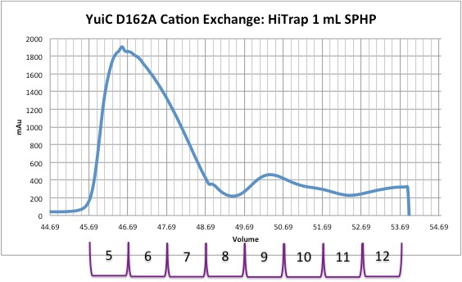
Supplementary Figure 1. Cation exchange chromatography profile of YuiC D162A
Buffer gradient 0-100% in 20 min (50 mM MES (pH 6.5), 2 mM βME and 1 M NaCl). Two peaks were observed, the monomer (fractions 5-7) and dimer (fractions 8-12) as shown by subsequent size exclusion chromatography on the equivalent fractions of the wild type protein.

